Homework # 1

Ruchi Panwar (rpanwar@kent.edu)

Advance Database

Fall 2015

Professor: Dr. Gregory S DeLozier

Sept 10, 2015

**1**. Get Python set up on your computer.

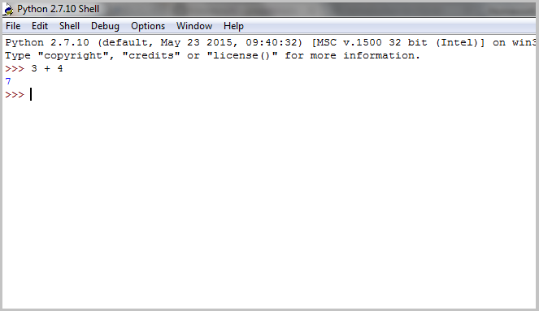

**2**. Get your PythonAnywhere account set up.

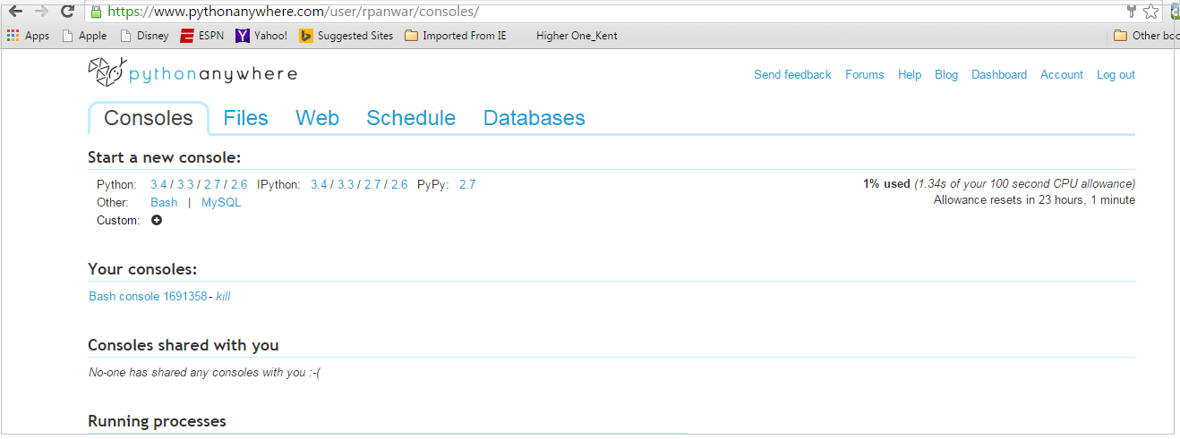

PythonAnywhere Link - <https://www.pythonanywhere.com/user/rpanwar/consoles/>

**3**.SQLite Tutorial Practicing - PythonAnywhere

3. 1 Create a table - employees

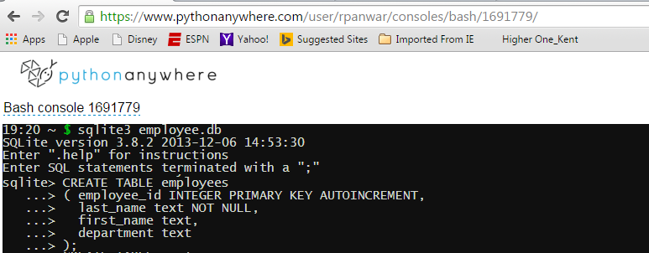

3. 2 Insert Data into a table (with or without the primary key - it's an integer so it will pop automatically)

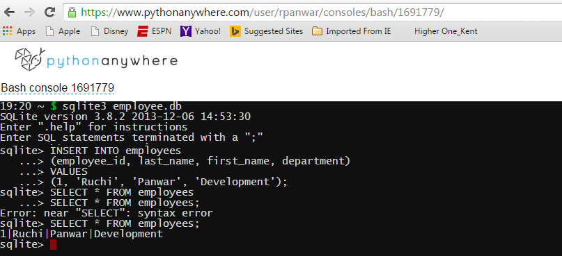

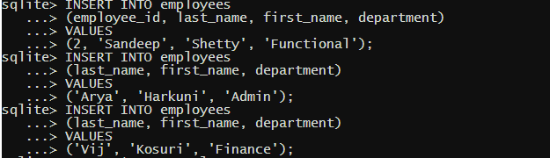

3. 3 Select data from the table employees



Change the output mode

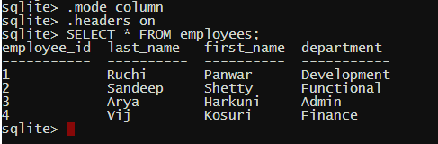

Select using Where condition

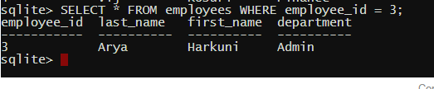

Select entries using IN and LIKE operators

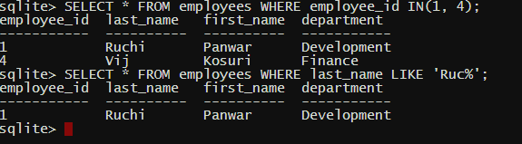

Select desired columns from the table

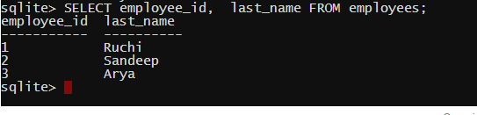

. 3. 4 Update/Modify data into the table - Changed the last name for employee_id = 4 (from Vij to vijetha)

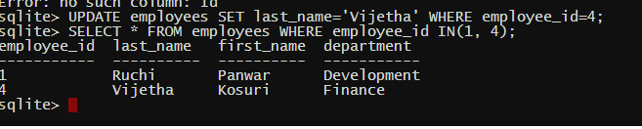

3. 5 Delete data from the table employees where employee_id = 4

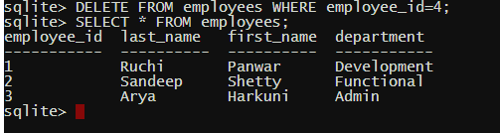

3. 6 Joins

we have two tables employees and emp_titles as follows

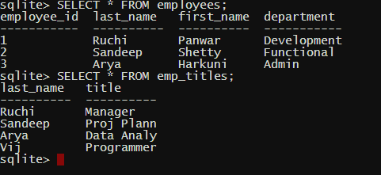

Inner Join

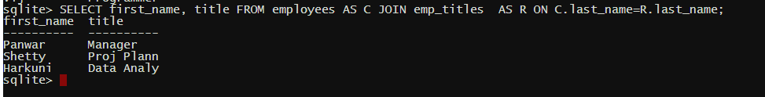

Left Outer join

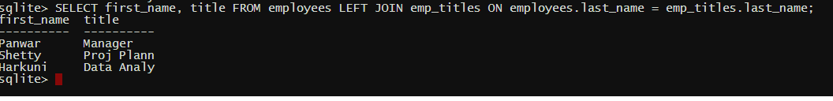

**4**.SQLite Tutorial Practicing - Python(Visual Studio)

4. 1 Create a table - employees

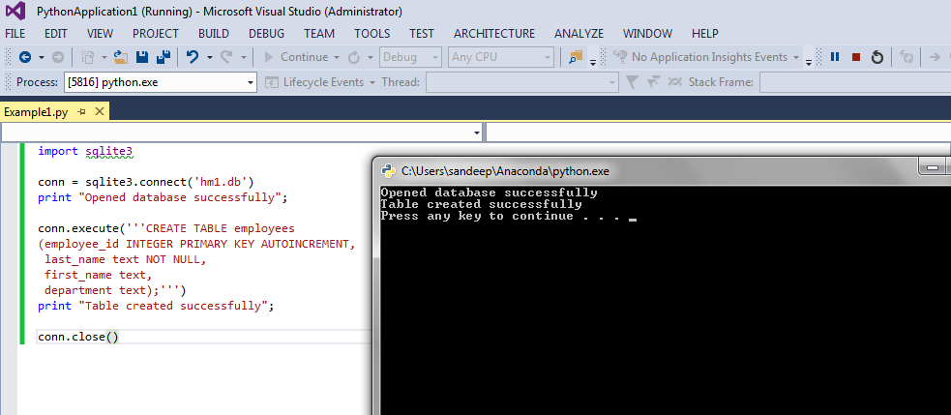

4. 2 Insert Data into a table (with or without the primary key - it's an integer so it will pop automatically)

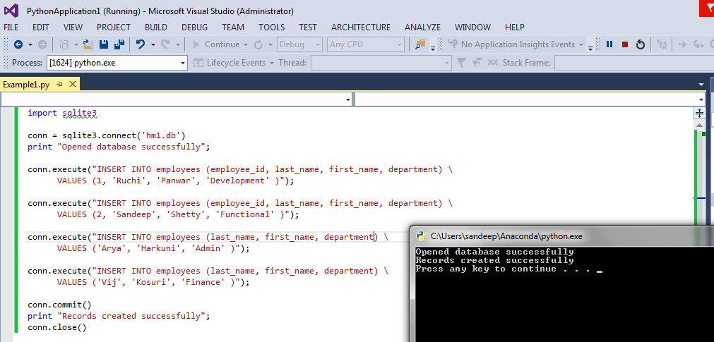

4. 3 Select data from the table employees

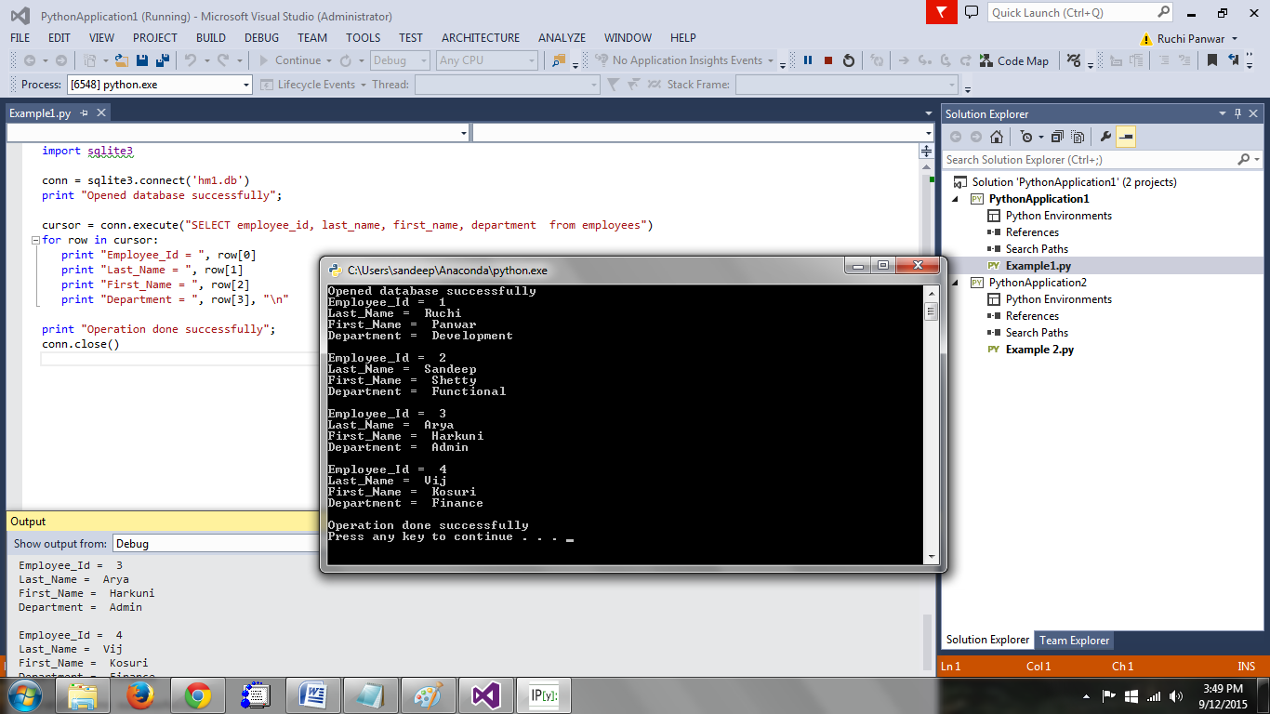

Select using Where condition

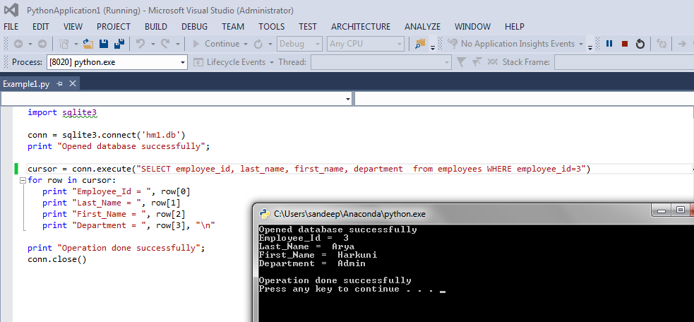

4. 4 Update/Modify data into the table - Changed the last name for employee_id = 4 (from Vij to vijetha)

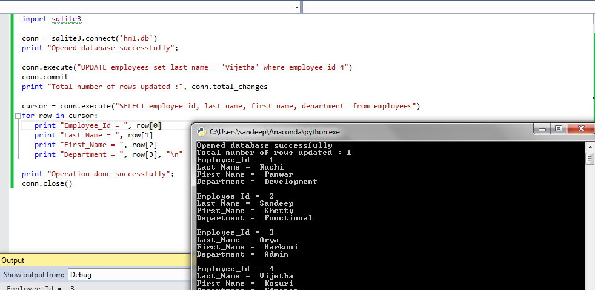

4. 5 Delete data from the table employees where employee_id = 4

